Press Release
Lustenau, 2018-11-24
This press release and the photos are available for downloading at www.ledon.at/en/press/

Andrea Bergerhoff new LEDON-CEO
General Manager change within the LED specialist from
Lustenau/Austria – expanding the successful business.
General Manager change within Ledon GmbH. Andrea Bergerhoff (52) takes over the management from Reinhard Weiss (62) who will retire for private reasons at the end of 2018 and spend more time with his family. „We thank Reinhard very much for his commitment in the past years and wish all the best for his future work-life balance “, says the new LEDON-CEO and shareholder Andrea Bergerhoff, who has extensive experience in the lighting industry.
Professional lighting solutions
LEDON GmbH with headquarter in Lustenau/Austria develops and manufactures professional lighting solutions for various applications – high-end LED Lamps for residential use, Indoor lighting solutions for industry and office applications providing superior light quality as well as easy installation and customized lighting solutions. The new segment of solar powered outdoor lighting solutions features LEDIVA – the designer pole luminaire harvesting and storing solar energy.
((1.091 characters))

LEDON researches, develops, produces and sells professional LED lighting solutions for the commercial, residential, hotel and industry sector. In addition, LEDON has a range of versatile LED lamps. Most recently, the business field of self-sufficient, solar outdoor lighting was founded in 2017. The company with around 30 employees is located in Lustenau (Vorarlberg/Austria). LEDON LED lighting
solutions are distributed via own employees as well as selected sales partners in numerous European countries.

Contact person:

LEDON GmbH
Erik Nielsen
Millennium Park 6
A-6890 Lustenau
Tel. +43 5577 21550 - 327
Mail erik.nielsen@ledon.com
www.ledon.at

.

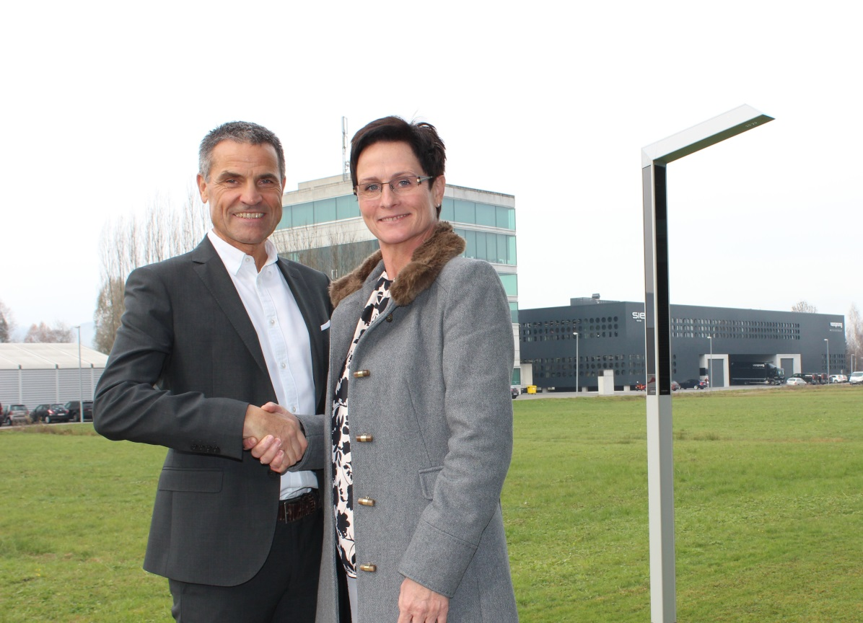

Andrea Bergerhoff takes over the management of LEDON from Reinhard Weiss, who will retire owing to family commitments.

Photo credit: LEDON
Date: 2018-11-24

